BUILDING A
BUILDING B

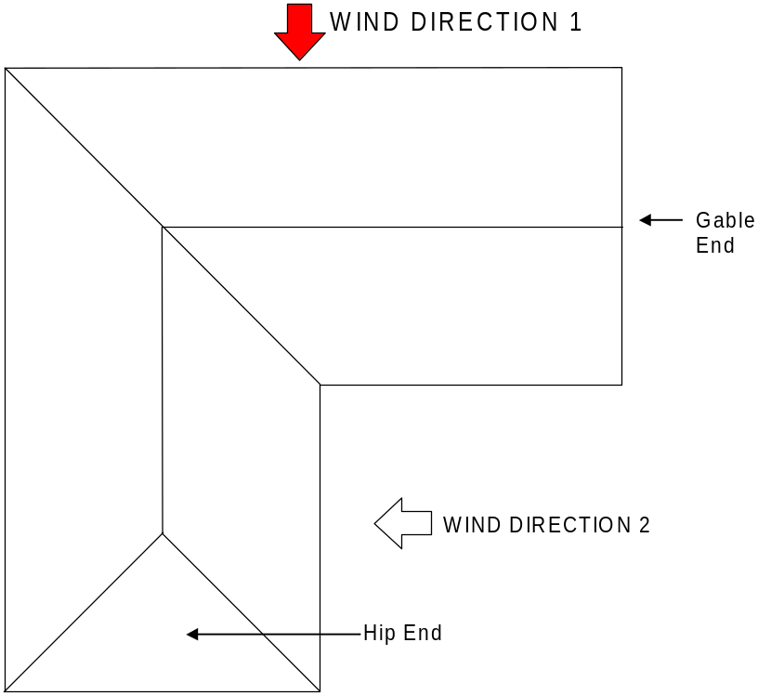
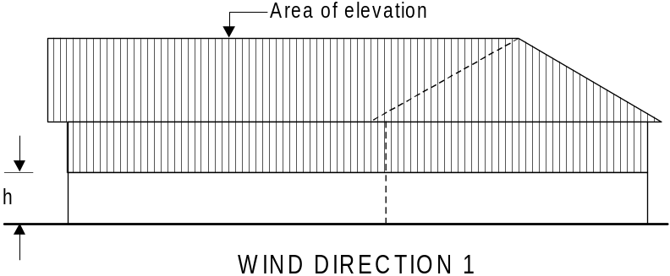
In this example, because the Building widths are the same for Building A & B, the total area for Wind direction 1 can be calculated and bracing distributed accordingly.

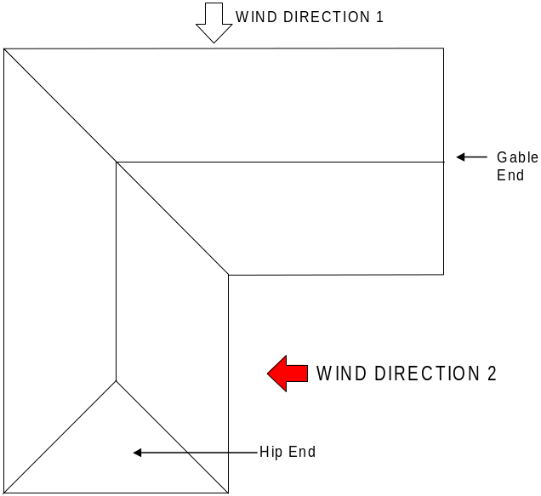
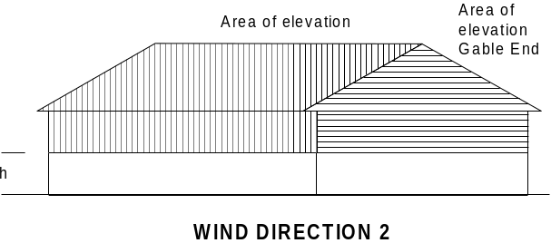
In wind direction 2, calculate and distribute bracing as though it were 2 separate buildings
Area of the gable end elevation must be calculated separately and the bracing required distributed accordingly.
BUILDING A
BUILDING B

